Project Report
On
Travelling Salesman Problem

Submitted by:
Atche Sravya - 170001013
B Rushya Sree Reddy - 170001014
Computer Science and Engineering
2nd year

Under the Guidance of
Dr. Kapil Ahuja

Department of Computer Science and Engineering
Indian Institute of Technology Indore
Spring 2019

1.Introduction:
Traveling Salesman Problem (TSP) is one of the important method in the application on transportation service. TSP can be illustrated as a salesman who must travel through all the cities designated by the shortest distances, where each city must be visited only once. Solution of the TSP is the path traversed by this salesman. Surely the best or optimal solution of this problem is the path with the shortest distance.
- The Travelling salesman problem is an NP-complete problem. So there is no polynomial time known solution for this problem.
- The solution to this problem can be found by using the following algorithmic approaches –
- Brute-force algorithm
- Dynamic Programming
- BackTracking
- Using MST (approximate solution)
- Christofides (approximate solution)
- Our objective here is to analyze and implement the above mentioned algorithmic approaches to this problem and also to analyze their time complexities .

To prove that Travelling Salesman Problem is NP-complete
We need to prove the following two results to show that TSP is NP-complete
• First, we need to prove TSP belongs to NP
• We know that Hamiltonian problem is NP complete, now we need to show that Hamiltonian problem is reducible to TSP.

- Proof for TSP ∈ NP :

Decision problem : Given n cities 1 to n, a non-negative integer distance d(i,j) between any two cities i and j and an integer bound B, can we find a tour visiting each city exactly once and return to starting city of length at most B?
More formally, given an instance I, certifier (i.e, a path
to check), also we are given B, we need to check this path is
valid or not.
This is easy to check. We iterate through each edge of path, check whether it is there or not and atlast check total length(sum of the distances between the cities in the given path) ≤ B.
This can be done in polynomial time complexity O(n).
Therefore TSP ∈ NP.

- Prove if X is an NP-complete problem, X ≤P TSP :

Hamiltonian Cycle Problem :
Given an undirected graph G(V,E), does it have a Hamiltonian cycle(a cycle visiting each node exactly once)?
We know that, it is an NP-complete problem.

To transform Hamiltonian cycle problem to TSP -
• Create a graph G’(V,E’) from Hamiltonian cycle instance G(V,E)
• G’ is a complete graph
• Edges in E’ also in E have an edge cost 0
• All other edges in E’ have an edge cost 1
Take any instance G(V,E) for the Hamiltonian cycle problem,
Convert it into an instance G’(VXV,d ), B = 0 of TSP,
d(i,j) = {
0 if (i,j) ∈ E ,
1 otherwise
}

G(V,E)
1
2
4
3
G’(V,E’)
1
2
4
3
0
0
0
0
1
1

Time complexity of the reduction is O(n^2) as there are n(n-1)/2
edges on a complete graph.
Problem : Is there a TSP on G’ such that total length of the tour is 0?
• If G has a Hamiltonian cycle, algorithm will return yes on input
G’(V,E)
• If G does not have a Hamiltonian cycle, algorithm will return no on
input G’(V,E)
If G’ has a cycle with total length of the path 0, every edge(i,j) has d(i,j) = 0, thus G has a Hamiltonian cycle.
We know that Hamiltonian cycle problem is NP-complete,
From the above two proofs we can say that TSP ∈ NP and there exists a NP-complete problem(Hamiltonian cycle problem) that can be reduced to TSP in polynomial time.
So, we can say that Travelling Salesman Problem is an NP-complete problem.

2. Algorithm Analysis :
Given a set of cities and distance between every pair of cities, the problem is to find the shortest possible route that visits every city exactly once and returns to the starting point.
Let us consider a graph G = (V, E), where V is a set of cities
and E is a set of weighted edges. An edge e(u, v) represents that vertices u and
v are connected. Distance between vertex u and v is d(u, v), which should be
non-negative.
- Brute-force Approach:
.
Algorithm:
- Consider one of the cities as starting point and ending point.
- Generate all (n-1)! permutations of cities.
- Calculate cost of every permutation and keep track of minimum cost permutation.
- Return the permutation with minimum cost.
2) Dynamic Programming Approach:
- Suppose we have started at city 1 and after visiting some cities now we are in city j. Hence, this is a partial route. We certainly need to know j, since this will determine which cities are most convenient to visit next. We also need to know all the cities visited so far, so that we don't repeat any of them. Hence, this is an appropriate sub-problem.

- For a subset of cities S Є {1, 2, 3, ... , n} that includes 1,and j Є S, let C(S, j) be the length of the shortest path visiting each node in S exactly once, starting at 1 and ending at j.
- When |S| > 1, we define C(S, 1) = ∞ since the path cannot start and end at 1.
- Now, let express C(S, j) in terms of smaller sub-problems . We need to start at 1 and end at j. We should select the next city in such a way that
C(S,j) = min C(S − {j},i) + d(i, j) where i ∈ S and i ≠ j
Algorithm:
C({1},1) = 0
for s = 2 to n do
for all subsets S ∈ {1,2,3,…,n} of size s and containing 1
C(S,1) = ∞
for all j ∈ S and j ≠ 1
C(S,j) = { min C(S − {j},i) + d(i, j) where i ∈ S and i ≠ j }
Return minj C({1,2,3,…,n} , j) + d(i, j)

3) Approximate using MST :
- Both of the above solutions are infeasible.
- In fact, there is no polynomial time solution available for this problem as the problem is a known NP-Hard problem.
- There are approximate algorithms to solve the problem though.
- The approximate algorithms work only if the problem instance satisfies Triangle-Inequality.
Triangle-Inequality:
The least distant path to reach a vertex j from i is always to reach j directly from i, rather than through some other vertex k (or vertices), i.e., dis(i, j) is always less than or equal to dis(i, k) + dist(k, j). The Triangle-Inequality holds in many practical situations.
- When the cost function satisfies the triangle inequality, we can design an approximate algorithm for TSP that returns a tour whose cost is never more than twice the cost of an optimal tour.
Algorithm :
- Let 1 be the starting and ending point for salesman.
- Construct MST with 1 as root using Prim’s Algorithm.
- List vertices visited in pre-order walk of the constructed MST and add 1 at the end.
- This algorithm may not produce the optimal route in all cases.
4) Back Tracking Algorithm :
Algorithm -
- Consider city 1 (let say 0th node) as the starting and ending point. Since route is cyclic, we can consider any point as starting point.
- Start traversing from the source to its adjacent nodes in dfs manner.
- Calculate cost of every traversal and keep track of minimum cost and keep on updating the value of minimum cost stored value.
- Return the permutation with minimum cost.
5) Christofides algorithm :
Let G = (V,w) be an instance of the travelling salesman problem. That is, G is a complete graph on the set V of vertices, and the function w assigns a nonnegative real weight to every edge of G. According to the triangle inequality, for every three vertices u, v, and x, it should be the case that w(uv) + w(vx) ≥ w(ux).
Algorithm :
- Create a minimum spanning tree T of G.
- Let O be the set of vertices with odd degree in T. By the handshaking lemma , O has an even number of vertices.
- Find a minimum-weight perfect matching M in the induced subgraph given by the vertices from O.
- Combine the edges of M and T to form a connected multigraph H in which each vertex has even degree.
- Form an Eulerian circuit in H.
- Make the circuit found in previous step into a Hamiltonian circuit by skipping repeated vertices (shortcutting).
3. Analysing the approximate algorithms and their time complexities :
- Brute-force approach:
- In this approach we choose one of the cities as starting and ending point, and then calculate cost of all the (n-1)! Permutations of cities by keeping track of the minimum cost Permutation . In the end we get the minimum cost tour.
- So the time complexity of the this algorithm is O(n!).
2) Dynamic Programming Approach:
- There are at the most n * 2^{n} sub-problems and each one takes linear time to solve.
- Therefore the total running time is O(n² * 2^{n})
- The time complexity is much less than O(n!), but still exponential. Space required is also exponential. So this approach is also infeasible even for slightly higher number of vertices.
3) BackTracking Algorithm :
- In each recursive call one of the remaining vertices is selected in the worst case. In each recursive call the branch factor decreases by 1. Recursion in this case can be thought of as n nested loops where in each loop the number of iterations decreases by one. Hence the time complexity is given by:
- T(n) = n*T(n-1)+O(1)
- T(n) = n*(n-1)*(n-2)*........ = O(n!)
4) Approximate using MST :
- This algorithm is 2-approximate…… i.e, the cost of the output produced by the above algorithm is never more than twice the cost of best possible output.
Proof of the fact that this algorithm is 2-approximate,
- Let us define a term full walk to understand this. A full walk lists all vertices when they are first visited in preorder, it also list vertices when they are returned after a subtree is visited in preorder.
1) The cost of best possible Travelling Salesman tour is never less than the
cost of MST. (The definition of MST says, it is a minimum cost tree that
connects all vertices).
2) The total cost of full walk is at most twice the cost of MST (Every edge
of MST is visited at-most twice)
3) The output of the above algorithm is less than the cost of full walk. In
above algorithm, we print preorder walk as output. In preorder walk,
two or more edges of full walk are replaced with a single edge. So if the
graph follows triangle inequality, then this is always true.
- Construction of an MST can be done in polynomial time in O(E logV) or O(V^2) time complexity and preorder walk can be done in O(n) time complexity. As only these two are involved in this algorithm, the overall time complexity is in polynomial time and not exponential or O(n!).
- So, this algorithm takes polynomial time to run but is not optimal solution but a 2-approximate solution.

5) Christofides algorithm :
The upper bound on computations for Christofides’ Algorithm is roughly
O(n|^4),significantly better than any of the exact solution approaches.
3/2 approximate -
The length of the tour produced by the algorithm is within 3/2 of the optimum.
Proof -
let C be the optimal traveling salesman tour, let O be the set of vertices with odd degree and T be minimum spanning tree of G .
Removing an edge from C produces a spanning tree, which must have weight at least that of the minimum spanning tree, implying that w(T) ≤ w(C). Next, number the vertices of O in cyclic order around C, and partition C into two sets of paths: the ones in which the first path vertex in cyclic order has an odd number and the ones in which the first path vertex has an even number. Each set of paths corresponds to a perfect matching of O that matches the two endpoints of each path, and the weight of this matching is at most equal to the weight of the paths. Since these two sets of paths partition the edges of C, one of the two sets has at most half of the weight of C, and from the triangle inequality its corresponding matching has weight that is also at most half the weight of C. The minimum weight perfect matching can have no larger weight, so w(M) ≤ w(C)/2. Adding the weights of T and M gives the weight of the Euler tour, at most 3w(C)/2. From the triangle inequality, shortcutting does not increase the weight, so the weight of the output is also at most 3w(C)/2.

4) Implementation and Results:
In this example, the cities are 1,2,3,4 with corresponding edges as shown in the figure,
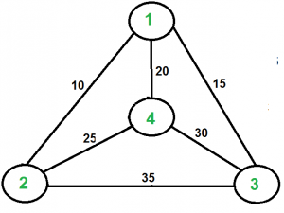
The tour with minimum total length is 1->2->4->3->1 with length os the tour equal to 80.
- Brute force implementation :
#include <bits/stdc++.h>
using namespace std;

int travellingSalesmanProblem(int **graph, int s,int V)
{
vector<int> path;
vector<int> vertex;
for (int i = 0; i < V; i++)
if (i != s)
vertex.push_back(i);

int min_path = INT_MAX;
do {
int current_pathweight = 0;

int k = s;
for (int i = 0; i < vertex.size(); i++) {
current_pathweight += graph[k][vertex[i]];
k = vertex[i];
}
current_pathweight += graph[k][s];

if(min_path > current_pathweight)
{
while(!path.empty())
{path.pop_back();}
k = s;
for (int i = 0; i < vertex.size()+1; i++)
{
path.push_back(k);
k = vertex[i];
}
}
min_path = min(min_path, current_pathweight);
}
while (next_permutation(vertex.begin(), vertex.end()));
cout << "The shortest tour is ";
for (int i = 0; i < vertex.size()+1; i++)
{
cout << path[i]+1 << "->"; }
cout << s+1 <<endl;
cout << "The length of the shortest tour is : " ;
return min_path;
}

int main()
{
int no_of_cities;
cout << "Enter the number of cities - ";
cin >> no_of_cities;
int **graph;
graph = new int*[no_of_cities];
for(int i=0;i<no_of_cities;i++)
{
graph[i] = new int[no_of_cities];
}
for(int i=0;i<no_of_cities;i++)
{
graph[i][i] = 0;
for(int j=i+1;j<no_of_cities;j++){
cout << "Enter the distance from city " << i+1 << " to " << j+1 << ": " ;
cin >> graph[i][j];
graph[j][i] = graph[i][j]; }
}
cout << endl;
int s = 0;
cout << travellingSalesmanProblem(graph, s,no_of_cities) << endl;
return 0;
}
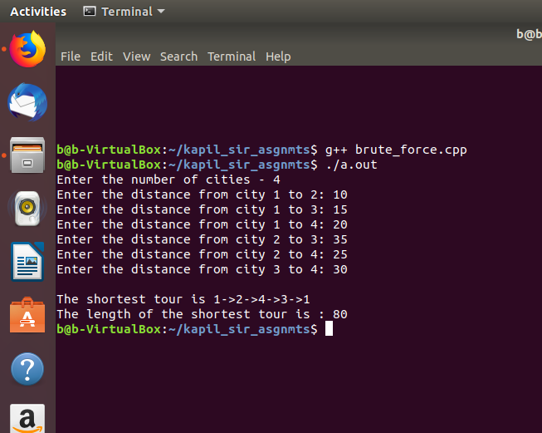

2) Dynamic implementation :

#include<iostream>
using namespace std;

#define INT_MAX 999999

int n=4;
int dist[4][4] = {
{0,10,15,20},
{10,0,35,25},
{15,35,0,30},
{20,25,30,0}
};
int VISITED_ALL = (1<<n) -1;

int dp[16][4];

int tsp(int mask,int pos){

if(mask==VISITED_ALL){
return dist[pos][0];
}
if(dp[mask][pos]!=-1){
return dp[mask][pos];
}

int ans = INT_MAX;

for(int city=0;city<n;city++){

if((mask&(1<<city))==0){

int newAns = dist[pos][city] + tsp( mask|(1<<city), city);
ans = min(ans, newAns);
}

}

return dp[mask][pos] = ans;
}

int main(){
for(int i=0;i<(1<<n);i++){
for(int j=0;j<n;j++){
dp[i][j] = -1;
}
}
cout<<"Travelling Saleman Distance is "<<tsp(1,0) << endl << endl << endl << endl;

return 0;
}

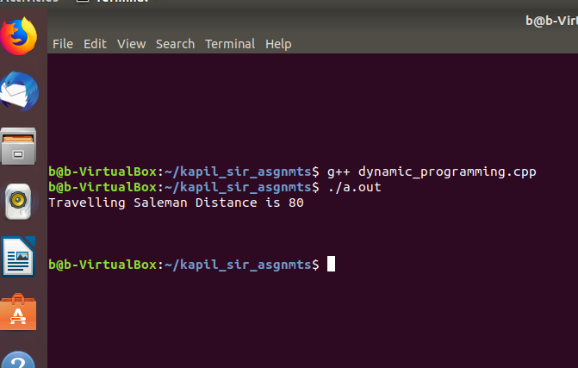

5) References:

https://www.slideshare.net/emrecankucukoglu/tsp-isnpcomplete
https://en.wikipedia.org/wiki/Christofides_algorithm
https://github.com/turin1602101/Algorithm/tree/master/Travel%20Salesman%20Problems

